CMIT 351 Project 1 Template

Please input the following correctly when the PKA file is opened as shown below:
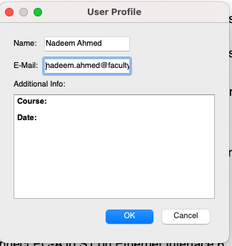

A starter network with labelled devices on the screen is presented already without them connected when you open the PKA file.

Part 1: Design the Local Area Network

[paste a screenshot of your final network diagram from Packet Tracer Activity file here]

Part 2: Create the basic switch configurations

2.1 Cable the network in PKA following the Instructions

2.2. Configure the basic switch functions following the Instructions

2.3 Configure the computers following the Instructions

2.4 Test and Validate Connectivity following the Instructions (2.5% of total)
- Paste Screenshots of the connectivity tests you ran on the PCs and the Switches in the PKA after configuration

Part 3: Define the VLANs following the Instructions (2.5% of total)
Describe how you test and validate the VLAN implementation.

Part 4: Implement VLAN Trunking following the Instructions (2.5%)
Describe how you test and validate the VLAN Trunking implementation.

