CMIT 351 Project 2 Template

Please input the following correctly when the PKA file is opened as shown below:

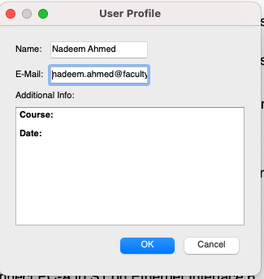

A starter network with labelled devices on the screen is presented already without them connected when you open the PKA file.

Part 1: Design the Local Area Network

[paste a screenshot of your final network diagram from Packet Tracer Activity file here]

Part 2: Create the basic switch configurations

2.1 Cable the network in PKA following the Instructions

2.2. Configure the basic switch functions following the Instructions

2.3 Configure the computers following the Instructions

2.4 Test and Validate Connectivity following the Instructions (2.5% of total)
- Note: This Packet Tracer Activity has built in connectivity tests that will run once you complete it and show the status and count towards the completion score.
- But to get the 2.5% you are required to use the PC command line to run ping tests for connectivity and paste screenshots of the connectivity tests you ran on the PCs in the PKA after configuration.

Part 3: Define the VLANs following the Instructions
Describe how you test and validate the VLAN implementation. (2.5% of total)

Part3b: Define the Router Sub-interfaces following the Instructions
Describe how you test and validate the sub-interface implementations. (2.5% of total)

Part 4: Implement VLAN Trunking following the Instructions
Describe how you test and validate the VLAN Trunking implementation. (2.5% of total)

