

IET 30800

Engineering Project Management & Economic Analysis

Assignment 2

Fall 2016

* Show your work when doing calculation and also, draw a cash flow diagram for each question. Type formulas and make sure in include units. Alternatively, you can write your answer and either scan it or take a picture and insert it into a Word document.
* Submit the assignment in Black Board only **(Only MS Word or PDF file. Don’t use the textbox in Blackboard to write your answers). No in-class submission.**

**Due:** Tuesday, 09-06-16, by class time in Blackboard

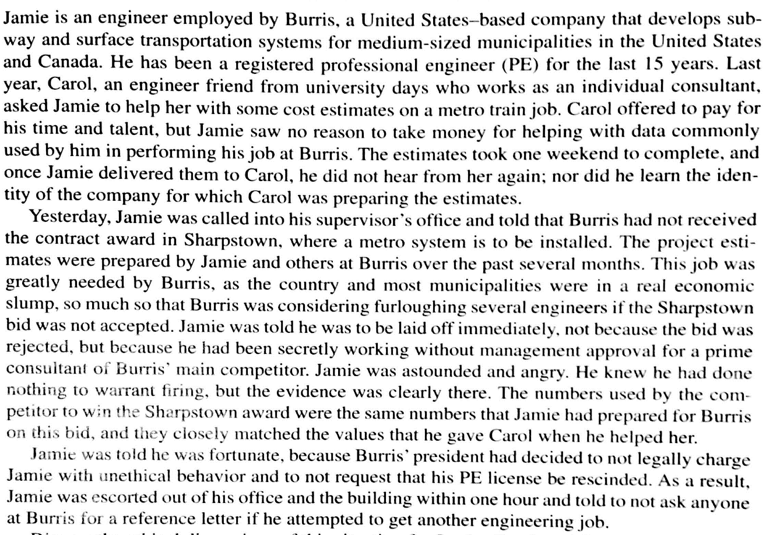1-

Discuss the ethical issues with this scenario for Jamie, Carol, and Burris’ management. Refer to the NSPE Code of Ethics for Engineering found in Blackboard under Lectures.

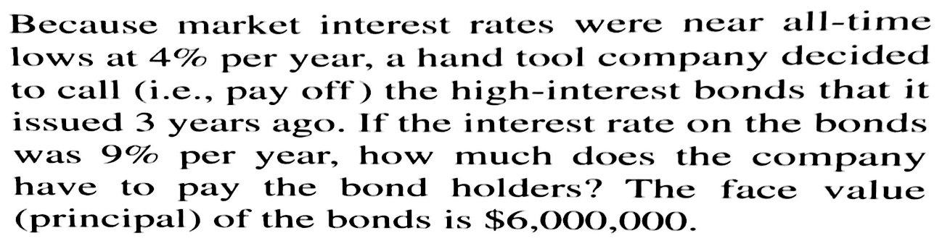2-

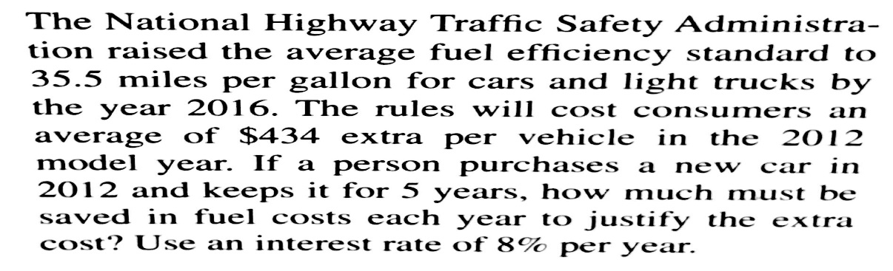3-

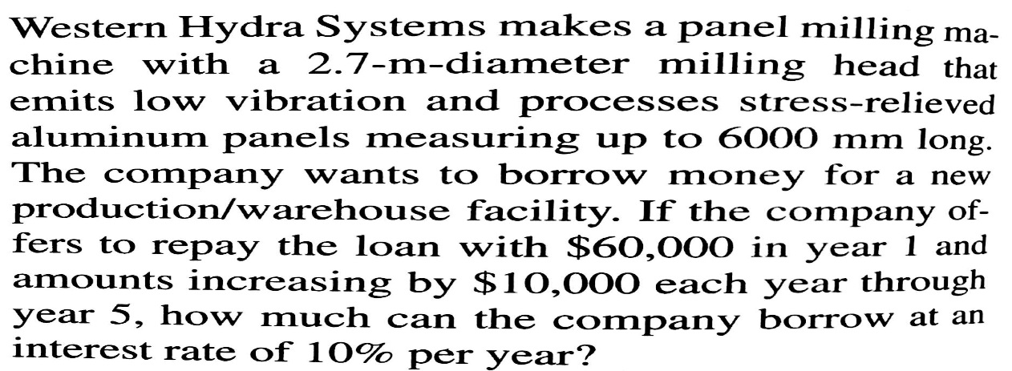4-

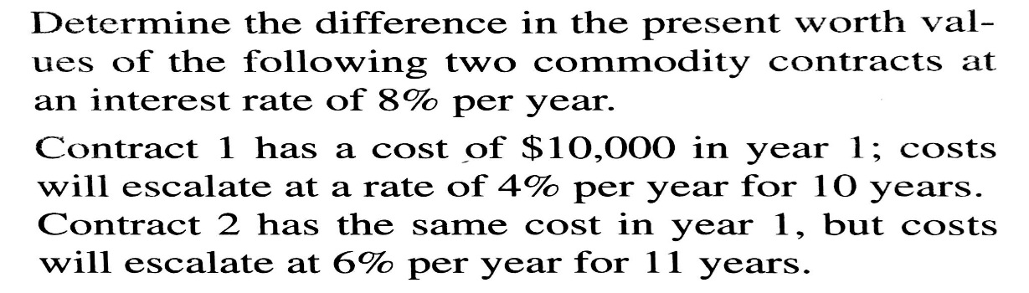5-