This module is designed to help you review, assess, and apply resources and tools that support development of an effective strategy. You will study a number of strategy planning tools and techniques in the assigned readings and apply them in your assignments. The tools discussed in this module are used by leaders and leadership teams in for-profit and not-for-profit organizations. They are performance measurement tools as well as planning techniques. You will get a chance to plan and use these tools in the assignments for this module.



* Synthesize a wide variety of economic, financial, and qualitative data to draw actionable managerial conclusions that convince others of your position and analytical conclusions.
* Identify actions that effectively integrate the primary business disciplines cross functionally to move the organization toward its mission and strategic goals, while being consistent with professional standards, social norms, and corporate ethics.

**Unit 2: Module 2 - Key Concepts in this Module**

|  |
| --- |
| **http://myeclassonline.com/ec/courses/AUO_files/AU_img.gifKey Concepts in this Module** |

|  |
| --- |
| http://myeclassonline.com/ec/courses/AUO_files/AU_spacer.gif |

|  |  |  |
| --- | --- | --- |
| * **Environmental scanning/SWOT**—The proposition behind the SWOT methodology is to allow an organization to assess its strengths, weaknesses, opportunities, and threats that will impact the business. When implemented in tandem with environmental scanning (that focuses on what is going on in the marketplace) and the economy, a SWOT can help an organization shore up its position in the marketplace. Ultimately, it is how the organization responds to the data and the subsequent actions that dictate the value of environmental scanning and SWOT. * **Five forces analysis**—Porter developed the five forces analysis process which includes exploring the threat of new competition, understanding the threat of substitute products or services, the bargaining power of customers (buyers), the bargaining power of suppliers, and the reality of the level of intensity of competitive/industry rivalry. * **Value chain analysis**—This tool encompasses analyzing direct and indirect activities that generate and deliver a company’s product or service to its customers. The analysis assesses each activity’s contribution to the competitive proposition through cost or differentiation. The analysis also explores any disadvantages. The culmination of information provides insight on informing the strategy. * **Performance analysis/benchmarking**—The purpose of benchmarking is to establish a reflective point to compare against. For example, a company may send out a customer feedback survey asking for input on its service. If the company receives an average rating of a 3 on a 5-point Likert scale, it may create a plan/initiative to improve this to secure a higher satisfaction rating of 4 over a period of time. The benchmark is 3 internally, and they may also choose to look at industry data on similar companies/organizations and benchmark against industry averages. This is one tool often used to help organizations to concretely measure the results of initiatives. * **Strategic issues**—Strategic issues often develop as a result of misaligned internal capabilities and external trends. This often prevents pursuing the right opportunities and not paying attention to marketplace (external) conditions that may threaten viability of the organization. Strategic reevaluation on a regular basis can help prevent strategic issues from popping up. Using environmental scans, SWOT analysis, and Porter’s five forces analysis can help reveal issues and provide ways to address them.   Porter, M. (1996). What is strategy? *Harvard Business Review 74*(6), 61–68. Retrieved from <http://www.ipocongress.ru/download/guide/article/what_is_strategy.pdf>  **Using the navigation on the left, please proceed to the next page.** |  |  |

|  |  |  |
| --- | --- | --- |
| http://myeclassonline.com/ec/courses/AUO_files/AU_spacer.gif |  | http://myeclassonline.com/ec/courses/AUO_files/AU_spacer.gif |
| [http://myeclassonline.com/ec/courses/AUO_files/au_cnt_alert.gif](javascript:;) |  | Help Desk 1-888-720-6654 |

**Unit 2: Module 2 - ABC Case Study—Evolving the Strategy**

|  |
| --- |
| **http://myeclassonline.com/ec/courses/AUO_files/AU_img.gifABC Case Study—Evolving the Strategy** |

|  |
| --- |
| http://myeclassonline.com/ec/courses/AUO_files/AU_spacer.gif |

|  |  |  |
| --- | --- | --- |
| Organizations may choose different strategic approaches including the following:   * **Retrenchment strategies** focus on tightening the belt (i.e., reducing operating costs and divestment of noncore assets). This often occurs in hard economic or recessionary times. * **Investment strategies** involve expenditure on innovation and market diversification. These approaches are often short-term and focused to make fast adjustments. They can also be risky when balanced with long-term strategies. * **Ambidextrous strategies**are exactly as the word suggests—a combination of retrenchment and investment. These approaches have inherent short-term benefits as well as some long-term risks.   One of the most famous company strategy moves was when, in the 1980s, Coke changed its formula in its Coca-Cola drink to a sweeter taste. The company did a huge market test complete with a large number of taste tests that were positive. The company invested in a large marketing campaign based on the taste tests. However, the general public was not impressed with the new flavor nor the marketing campaign. Coke classic was reintroduced in an ambidextrous strategy in terms of retrenching and investment. As you can see, performance analysis does not always work.  Truly, it is about assessing which strategy is best for the organization. ABC eLearning’s management attributed the company’s growth and success to the following, using a general to specific and measurable approach:   * **Developing a strategy**—This allowed for flexibility and included critical factors such as core business, marketplace needs/trends/demands, economic indicators for industry growth, and the ability to build in channel partners and easily expand the business beyond its core services. * **Executing the strategy**—This covered what, who, and how the plan would be executed. It also covered the clear metrics established each fiscal year that would demonstrate the strategy was executed properly and was working.   Although ABC was set up in 2003, developing the strategy was an evolving process. The leader of the organization came across and referenced *Change by Design*by Tim Brown as a resource that helped articulate one of the efforts within the organization. The leader found the following points particularly inspiring:   * Do not look at things like a problem, look at them like a project to work on and improve. * Use cross-functional teams within the organization to innovate, ideate, implement, and keep evolving.   Brown, T. (2009). *Change by design: How design thinking transforms organizations and inspires innovation*. New York, NY: Harper Collins.  **Using the navigation on the left, please proceed to the next page.** |  |  |

|  |  |  |
| --- | --- | --- |
| http://myeclassonline.com/ec/courses/AUO_files/AU_spacer.gif |  | http://myeclassonline.com/ec/courses/AUO_files/AU_spacer.gif |
| [http://myeclassonline.com/ec/courses/AUO_files/au_cnt_alert.gif](javascript:;) |  | Help Desk 1-888-720-6654 |

lthough one would perceive the activities defined in this course as consistent practices derived from common sense, it is surprising how often organizations will skip the basics (i.e., a thorough five forces analysis of the industry; key factors and trends in any other areas affecting the industry; and a SWOT analysis that considers internal and external factors).

Basic fundamental processes are neglected as companies try to become agile, innovative, and creative. The US automobile industry of the later part of the twentieth century is an example. In many of the automobile companies, quality control processes were sacrificed for sales and marketing techniques. The fundamentals of the production model were forfeited for perceived financial gain at the cost of reputation and long-term sustainability.

The ABC eLearning company did not skip all the basics, but they also did not dive in or address elements of all the basics that could have prevented some of their early missteps. One specific element was based on a better understanding of the external environment compared to capabilities to support an expanding customer base with competing affiliate requirements (i.e., who is the priority, whether it is the affiliate that pays very little for the services but keeps the lights on, or the new external customers that pay more and offer more opportunity for increased growth). This example reiterates the importance of always starting with a solid foundation and addressing the fundamentals around internal and external balance, as well as market position and priority.

**Building on Fundamentals**

Organizations that stay true to the fundamentals consistently yield better results and can catch and remedy marketplace decline faster than their competitors. Jim Collins (2009) wrote about this to some degree in *How the Mighty Fall and Why Some Companies Never Give In*. Although leadership and leadership decisions play a key role, the essence includes staying true to the basics as a foundation for success. This is akin to why Porter’s five forces analysis is still considered a useful resource or tool in business.

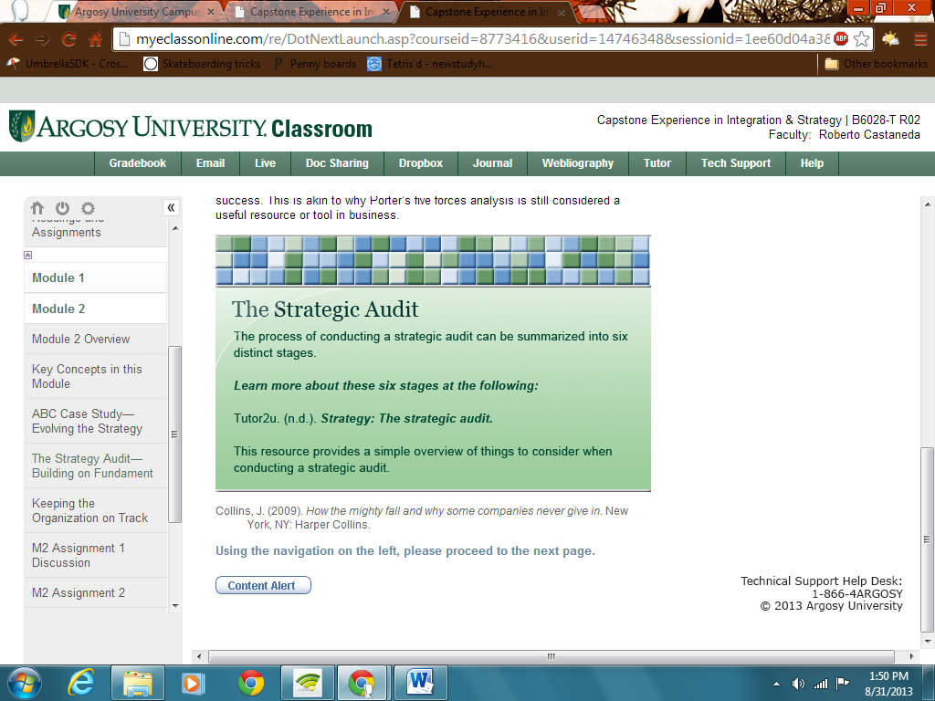

<http://tutor2u.net/business/strategy/Strategic_audit.htm>

Collins, J. (2009). *How the mighty fall and why some companies never give in*. New York, NY: Harper Collins.

# Unit 2: Module 2 - Keeping the Organization on Track

|  |
| --- |
| **http://myeclassonline.com/ec/courses/AUO_files/AU_img.gifKeeping the Organization on Track** |

|  |
| --- |
| http://myeclassonline.com/ec/courses/AUO_files/AU_spacer.gif |

|  |  |  |
| --- | --- | --- |
| Most successful organizational leaders can quickly share what they believe are their strengths, weaknesses, opportunities, and threats. This is a sign that they are paying regular attention to what is influencing their business and business results. However, the key is how they proactively manage or react to address these in a way that keeps the organization on track with its goals. Consider this as you work on the assignments for this module.  For example, Glaxo’s board wanted its chief executive officer (CEO) to launch a new line of products in a new market. The CEO decided the new ventures need to be integrated into the company’s strategic plan. The CEO met with key leadership staff and did a SWOT analysis exercise to identify internal and external forms and forces. The CEO then used the SWOT findings to guide the development of goals and objectives for the new ventures that aligned with the company vision and mission. The findings also showed what kind of resources and forms and forces would be needed and accounted for. The SWOT findings can be operationalized and measured against.  In the assignments,you will review factors and trends that influence strategy development as well as conduct an external environmental scan of your business unit.  **Using the navigation on the left, please proceed to the next page.** |  |  |

|  |  |  |
| --- | --- | --- |
| http://myeclassonline.com/ec/courses/AUO_files/AU_spacer.gif |  | http://myeclassonline.com/ec/courses/AUO_files/AU_spacer.gif |
| [http://myeclassonline.com/ec/courses/AUO_files/au_cnt_alert.gif](javascript:;) |  | Help Desk 1-888-720-6654 |