**Required Readings**

* Mascarenhas, O. A., Kesavan, R., & Bernacchi, M. (2004). Customer value-chain involvement for co-creating customer delight. *The Journal of Consumer Marketing, 21*(7), 486–496. (ProQuest Document ID: 220125989)  <http://search.proquest.com.libproxy.edmc.edu/docview/220125989?accountid=34899>
* Osarenkhoe, A. (2008). What characterises the culture of a market-oriented organisation applying a customer-intimacy philosophy? *Journal of Database Marketing & Customer Strategy Management, 15*(3), 169–190. (ProQuest Document ID: 233312287) <http://search.proquest.com.libproxy.edmc.edu/docview/233312287?accountid=34899>
* Porter, M. (1996). What is strategy? *Harvard Business Review 74*(6), 61–78. Retrieved from[http://libproxy.edmc.edu/login?url=http://search.ebscohost.com/  
  login.aspx?direct=true&db=bsh&AN=9611187954&site=ehost-live](http://libproxy.edmc.edu/login?url=http://search.ebscohost.com/login.aspx?direct=true&db=bsh&AN=9611187954&site=ehost-live)

**Recommended Readings**

* Kahn, S. R. (2010). Capitalism at the crossroads: Next generation business strategies for a post-crisis world.*Choice, 48*(4), 738. (ProQuest Document ID: 818556268)<http://search.proquest.com.libproxy.edmc.edu/docview/818556268?accountid=34899>
* Shore, H. (2008, March). Are you creating raving fans? *Biznik*. Retrieved from<http://biznik.com/articles/are-you-creating-raving-fans>

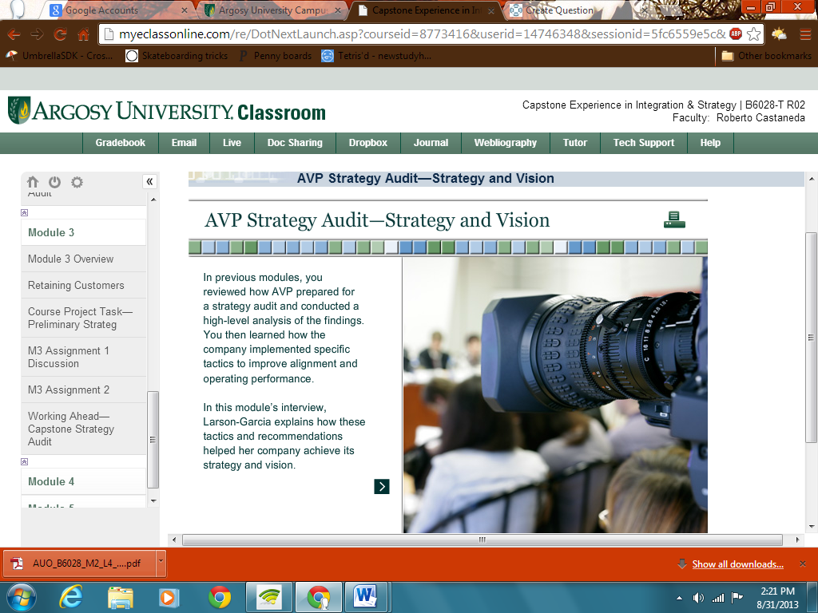

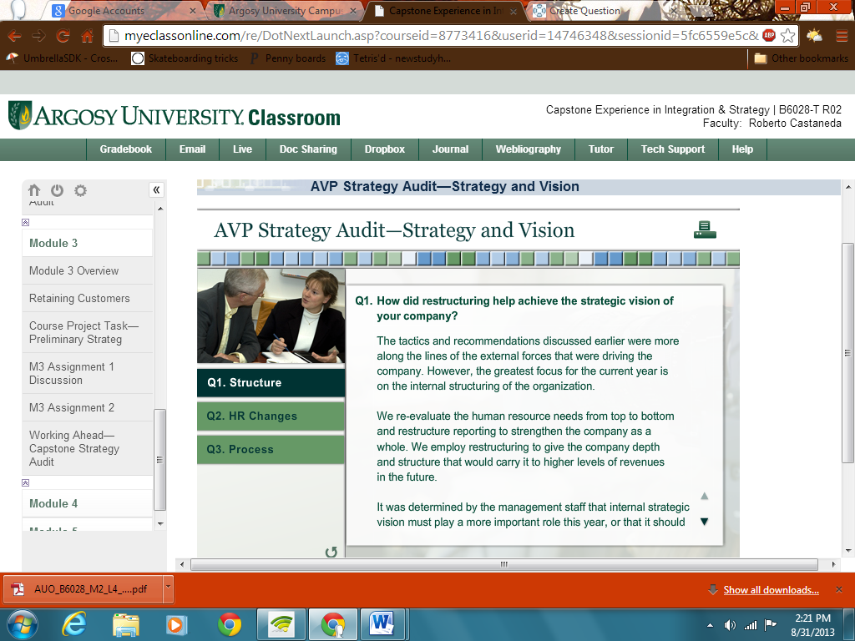

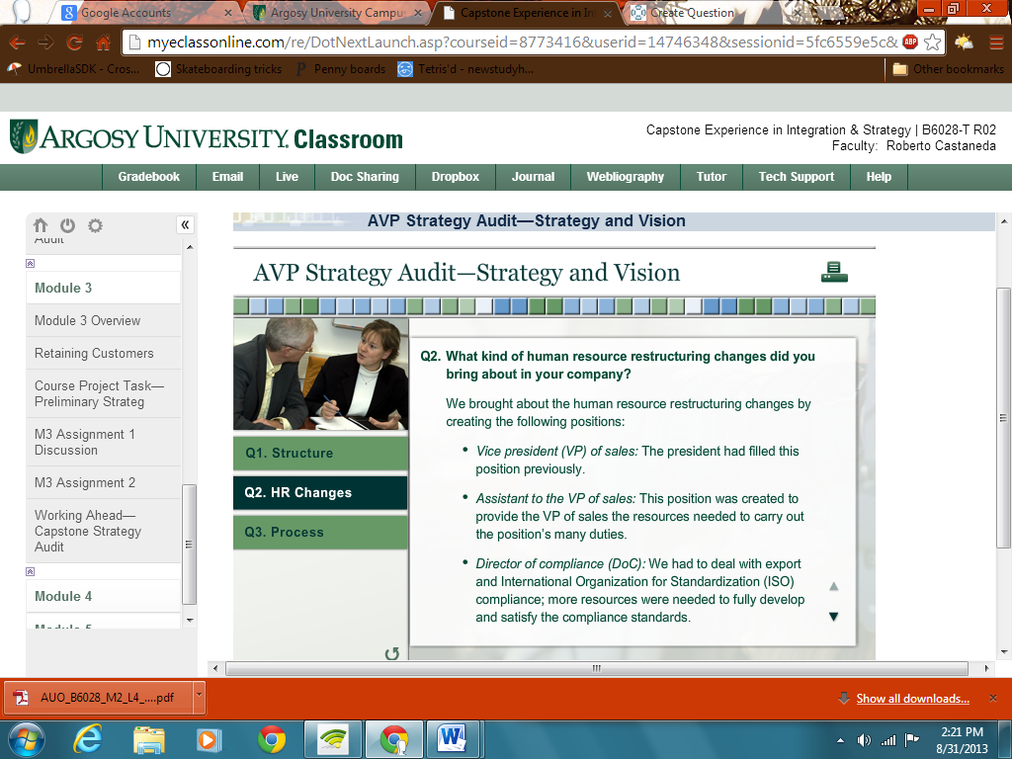

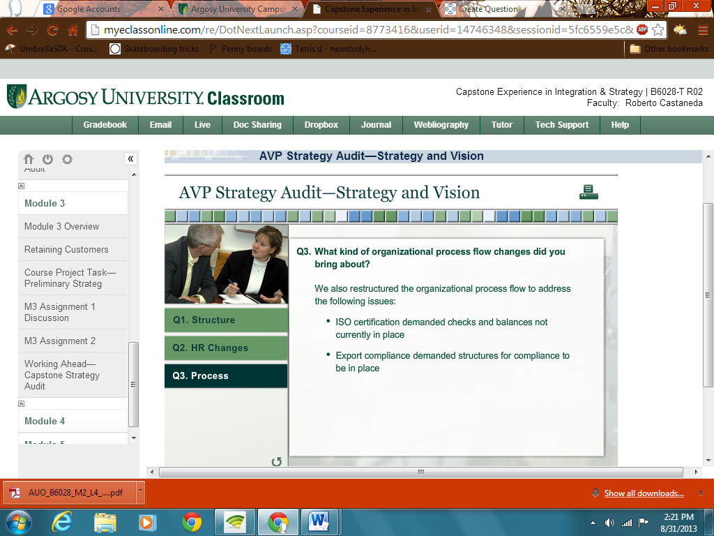

|  |
| --- |
| **Retaining Customers** |

|  |
| --- |
| http://myeclassonline.com/ec/courses/AUO_files/AU_spacer.gif |

|  |
| --- |
| Ken Blanchard and Sheldon Bowles (1993) said it best in *Raving Fans:* *A Revolutionary Approach to Customer Service:* “If you really want to ‘own’ a customer, if you want a booming business, you have to go beyond satisfied customers and create Raving Fans” (p. 13) The raving fan approach in tandem with Porter’s five forces model can help business managers and leaders develop an effective approach. This element is a reminder that you can get business and that is no inexpensive endeavor. However, keeping business and growing it is just as important. In fact, new customer acquisition is often more costly than keeping and growing a current customer.  **Business Referrals**  Some business experts espouse a method of gathering customer satisfaction information. Although you may ask a variety of questions to better understand what is working and what is not in terms of customer satisfaction, there is only one question that needs to be asked: “Would you refer our business to someone else?” The proposition is that if the answer is “Yes,” then it covers almost everything at a fundamental level. In addition, satisfaction with the service or product is high enough that the customer would refer your business to others. Ultimately, this is what it boils down to: satisfaction supports growth.  In this module, you will examine customer satisfaction and growth and acquire a better understanding of how supply chain management works. Walmart’s success in managing its supply chain has enabled it to dominate its competition, maintain an inventory, and meet customer demand without oversupply costs and consequences (Accounting Software Advisor [ASA] Research, n.d.). As you work through the assignments in this module, consider this and how supply chain management influences or drives business.  ASA Research. (n.d.). *Supply chain*. Retrieved from<http://www.asaresearch.com/ecommerce/supplychain.htm>  Blanchard, K., & Bowles, S. (1993). *Raving fans: A revolutionary approach to customer service.*New York, NY: William Morrow and Company.  **Using the navigation on the left, please proceed to the next page.** |

**Unit 3: Module 3 - Course Project Task— Preliminary Strategy Audit**

|  |
| --- |
| **http://myeclassonline.com/ec/courses/AUO_files/AU_img.gifCourse Project Task: Preliminary Strategy Audit** |

|  |
| --- |
| http://myeclassonline.com/ec/courses/AUO_files/AU_spacer.gif |

|  |  |  |
| --- | --- | --- |
| You will also submit your preliminary strategy audit as part of LASA 1 by the end of this module.  Those with significant business experience understand the value of this assignment—that it is an important process related to business review and assessment and potential strategic realignment. For those with less experience, one way to approach this aspect of the course and the development of this project is to equate it to building a house. The land is always graded and essential plumbing and other internal organs that come from the outside to support the house have to be in place prior to laying the foundation and framing the house. The reason builders build in phases is exactly why successful businesses do the following:   * Create a vision * Develop strategies around their vision * Plan for implementation or execution * Assess   This methodical sequencing prevents problems. Review your preliminary strategy audit and make sure you have covered all the required elements for this phase of the project. You could also use a checklist, and possibly have someone review and ask them to question what you have presented or developed thus far.  In the assignments for this module, you will also explore the supply chain. The supply chain is the links in the logistics process.  **Using the navigation on the left, please proceed to the next page.** |  |  |

|  |  |  |
| --- | --- | --- |
| http://myeclassonline.com/ec/courses/AUO_files/AU_spacer.gif |  | http://myeclassonline.com/ec/courses/AUO_files/AU_spacer.gif |
| [http://myeclassonline.com/ec/courses/AUO_files/au_cnt_alert.gif](javascript:;)  In **Module 1**, you had the opportunity to review the capstone course project. To stay on track to deliver your strategy audit in **Module 5**, you should start framing your project including the following aspects:   * Title * Agenda * Summary of audit * Recommendations * Key measurements * Risks and benefits * Call to action * Next steps   Be sure to let your instructor know if you have any questions or have met any major obstacles.  Revisit the **Overview of LASAs** section in **Module 1** for reviewing information about the LASA. |  | Help Desk 1-888-720-6654 |