**Required Readings**

* Becher, J. D. (2005). Operational alignment: Bridging the gap between strategy and execution.*Business Performance Management Magazine, 3*(1), 11. (ProQuest Document ID: 218383095)<http://search.proquest.com.libproxy.edmc.edu/docview/218383095?accountid=34899>
* Kaplan, R. S., & Norton, D. P. (2007). Using the balanced scorecard as a strategic management system. *Harvard Business Review, 85*(7/8), 150–161. (ProQuest Document ID: 227841808)<http://search.proquest.com.libproxy.edmc.edu/docview/227841808?accountid=34899>
* Roh, J. J., Hong, P., & Park, Y. (2008). Organizational culture and supply chain strategy: A framework for effective information flows. *Journal of Enterprise Information Management, 21*(4), 361–376. (ProQuest Document ID: 220044319)<http://search.proquest.com.libproxy.edmc.edu/docview/220044319?accountid=34899>
* Smith, B. D. (2007). Strategy-making: What works is what fit*s. European Business Forum, 28,*32–37*.* (ProQuest Document ID: 224670404)<http://search.proquest.com.libproxy.edmc.edu/docview/224670404?accountid=34899>
* Zagotta, R., & Robinson, D. (2002). Keys to successful strategy execution. *The Journal of Business Strategy, 23*(1), 30–34. (ProQuest Document ID: 202724421)<http://search.proquest.com.libproxy.edmc.edu/docview/202724421?accountid=34899>
* Zuckerman, A. (2002). Strong corporate cultures and firm performance: Are there tradeoffs?*Academy of Management Executive, 16*(4), 158–160. (EBSCO AN: 17534385)  
  [http://libproxy.edmc.edu/login?url=http://search.ebscohost.com/  
  login.aspx?direct=true&db=bsh&AN=17534385&site=ehost-live](http://libproxy.edmc.edu/login?url=http://search.ebscohost.com/login.aspx?direct=true&db=bsh&AN=17534385&site=ehost-live)

.

**Unit 4: Module 4 - Module 4 Overview**

|  |
| --- |
| **http://myeclassonline.com/ec/courses/AUO_files/AU_img.gifModule 4 Overview** |

|  |
| --- |
| http://myeclassonline.com/ec/courses/AUO_files/AU_spacer.gif |

|  |  |  |  |
| --- | --- | --- | --- |
| This module is designed to explore beyond hard scientific tactics and formulae to examine the human component and its influence on strategy. It will also help you triangulate both the qualitative and quantitative elements of developing and implementing an audit that can serve as the foundation for a strategic plan.  Economic factors, product and service demand, and application of proven models can provide a solid foundation for any strategy; however, understanding the human component of business and leadership is a critical aspect of organizational success. You will draw from prior MBA coursework on leadership concepts and synthesize with materials provided in this module to gain a better understanding of this aspect of strategy.  As we further explore developing and executing strategy, a story comes to mind about making sure you are doing the right work, at the right time and staying aligned with executing the strategy.   |  | | --- | | After a big snowstorm, a man went out to the street to dig out his car. He spent a good thirty minutes shoveling and started an initial scraping of snow and ice from the windows when a woman came outside and gave him a big smile. She walked up to the car saying, “I am not sure why you did this but I sincerely thank you and appreciate your hard work.” He looked at her puzzled and said, “I am not sure what you mean.” She clicked the keys in her hand and the car he had been shoveling out beeped. She said, “You just shoveled my car out; thank you.” The look on his face was priceless. |   How often do we jump into work before we ask questions or make sure we fully understand the desired end result? The answer likely is, too often. In the anecdotal story, the man was doing “fake work.” He did not verify he was doing the right work; he just dove in and started. This happens not just in our personal lives but all too often in our professional and work lives.  Business, at its heart, is all about people—individuals and groups or personal taste and groupthink. There are proven tools to help assess and evaluate values, culture, and leadership in organizations. Those tools will be examined in this module. |  | http://myeclassonline.com/ec/courses/AUO_files/LearnOutcomes_sidebar_AU.gif   * Analyze the complexity of ethical situations and corporate social responsibility and their impact on decision making in business. |

|  |  |  |
| --- | --- | --- |
|  |  | http://myeclassonline.com/ec/courses/AUO_files/AU_spacer.gif |
| [http://myeclassonline.com/ec/courses/AUO_files/au_cnt_alert.gif](javascript:;) |  | Help Desk 1-888-720-6654 |

# Unit 4: Module 4 - Considering Cultural Norms

|  |
| --- |
| **http://myeclassonline.com/ec/courses/AUO_files/AU_img.gifConsidering Cultural Norms** |

|  |
| --- |
| http://myeclassonline.com/ec/courses/AUO_files/AU_spacer.gif |

|  |  |  |
| --- | --- | --- |
| In addition to reeling in individuals so they do not go down the wrong path or focus on items that may not be the priorities, consideration has to be given to the organization’s cultural norms. You need to ask the following questions:   * Is there a “hurry-up” culture with an over-zealous sense of urgency that is more about getting it done fast then getting it done well? * Is there a culture of “review and refine, review and refine” before moving forward and making change happen? * Is the approach methodical and deliberate with an appropriate sense of urgency?   This question is hard to answer because it requires talking to people who live and work within the organization as well as observing the environment over time. That said, most managers, leaders, and staff-level team members can give you their perspective, and it is usually an accurate representation. Though the perspective typically has a slight personal twist to it, that is to be expected.  **“Fake Work”**  When one of the authors of Fake Work and strategy and execution expert Brent Peterson was asked about issues with organizations implementing strategies, he offered the following:  My experience leads me to believe that developing a great strategy is not the big problem. The big problem is aligning each employee in the organization to understand the strategy and make it part of their daily work. If this does not occur, the strategy does not work and the organization does not effectively execute. (Peterson, 2012)  Consider the following steps to complete a current status review:   * Review all the strategy documents in the organization. * Interview the entire executive team. * Randomly have many employees throughout the organization complete the organizational strategy audit. All work being done in an organization that is not strategically related is considered “fake work” (Peterson, 2012).   Peterson, B. (2012, April). Driving business results through well planned strategy and execution. Presented at a workshop for the Argosy University College of Business Speaker Series, Argosy University, Washington, DC.  **Using the navigation on the left, please proceed to the next page.** |  |  |

|  |  |  |
| --- | --- | --- |
| http://myeclassonline.com/ec/courses/AUO_files/AU_spacer.gif |  | http://myeclassonline.com/ec/courses/AUO_files/AU_spacer.gif |
| [http://myeclassonline.com/ec/courses/AUO_files/au_cnt_alert.gif](javascript:;) |  | Help Desk 1-888-720-6654 |

# Unit 4: Module 4 - Implementing the Strategy

|  |
| --- |
| **http://myeclassonline.com/ec/courses/AUO_files/AU_img.gifImplementing the Strategy** |

|  |
| --- |
| http://myeclassonline.com/ec/courses/AUO_files/AU_spacer.gif |

|  |  |  |
| --- | --- | --- |
| After the current strategy and performance review is complete, you must proceed through the following steps outlined in this course to help you develop the strategic plan:   * Environmental scanning/SWOT * Five forces analysis * Value chain analysis * Performance analysis/benchmarking * Strategic issues   A critical part of the process before finalizing and implementing any strategy is to ensure alignment within the organization with management and staff. Ultimately, it is the combination of the two that executes and delivers the desired results. Without understanding and aligning with the strategy, the ability to achieve success is reduced.  Generally, about 60% of the organizations I work with have a good strategy but only about 20% of all organizations are performing their best and achieving their strategic goals. (Peterson, 2012)  Why does this occur? Generally, it is a lack of understanding and alignment, which creates a focus on “fake work” and inhibits success.    <http://internationalbusinesstips.net/how-to-audit-your-business-strategy/>  Peterson, B. (2012, April). Driving business results through well planned strategy and execution. Presented at a workshop for the Argosy University College of Business Speaker Series, Argosy University, Washington, DC.  **Using the navigation on the left, please proceed to the next page.** |  |  |

|  |  |  |
| --- | --- | --- |
|  |  | http://myeclassonline.com/ec/courses/AUO_files/AU_spacer.gif |
|  |  | **Unit 4: Module 4 - Internal Assessment of Strategy**     |  | | --- | | **http://myeclassonline.com/ec/courses/AUO_files/AU_img.gifInternal Assessment of Strategy** |  |  | | --- | | http://myeclassonline.com/ec/courses/AUO_files/AU_spacer.gif |  |  |  |  | | --- | --- | --- | | The focus in this module is on internal assessment and how employee behaviors align with the mission, vision, and values as well as executing the strategy that drives the achievement of goals. It is important to research how an organization’s culture governs strategy and conduct an internal environmental scan and organizational assessment for the strategy audit. Access to an organization’s leadership is important in order to be able to complete the strategy audit. This is particularly true as it relates to interviewing leadership and observing behaviors in the organization that can help you better understand how the culture impacts the company (both positively and negatively).      **Using the navigation on the left, please proceed to the next page.** |  |  |  |  |  |  | | --- | --- | --- | | http://myeclassonline.com/ec/courses/AUO_files/AU_spacer.gif |  | http://myeclassonline.com/ec/courses/AUO_files/AU_spacer.gif | | [http://myeclassonline.com/ec/courses/AUO_files/au_cnt_alert.gif](javascript:;) |  | Help Desk 1-888-720-6654 | |

**AVP Strategy Audit—External Resources**

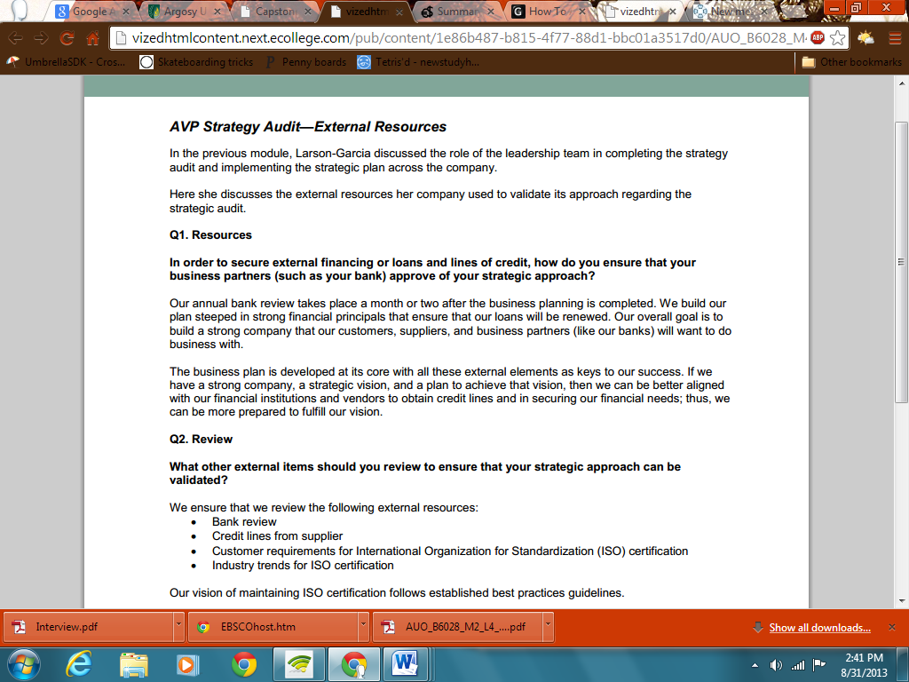

# Unit 4: Module 4 - Strategic Goals and Measures

|  |
| --- |
| **http://myeclassonline.com/ec/courses/AUO_files/AU_img.gifStrategic Goals and Measures** |

|  |
| --- |
| http://myeclassonline.com/ec/courses/AUO_files/AU_spacer.gif |

|  |  |  |
| --- | --- | --- |
| Critical to the strategy audit process is understanding what to measure and how to measure it based on the mission and goals of the organization.  Key performance indicators (KPIs) are one such measure that refer to identified items in the business that are considered essential to the overall success of the business. KPIs can include new customer acquisition, customer retention, and new product development.  Another measure is benchmarking best practices, which you examined in **Module 2**. The purpose of benchmarking is to establish a reflective point to compare against. This is one tool often used to help organizations to concretely measure the results of initiatives.  The balanced scorecard is another way to look at KPIs. The balanced scorecard is based on a prescribed or planned set of performance objectives that will be measured and evaluated regularly. The scorecard outlines specific indicators and measurements that will indicate whether the company is successful or unsuccessful in progressing toward the prescribed vision through execution of strategy.  A balanced scorecard presents organizational performance on four primary groups of measures:   1. Financial 2. Customer (external stakeholder) 3. Learning and growth 4. Internal processl     **Business Metrics and Performance**  There are pros and cons to using KPIs and the balanced scorecard approach. In addition, the right metrics and management adoption or acceptance is critical. At the ABC eLearning Company, they had the right combination of metrics and management acceptance. In addition, they offered quarterly incentives for performance scores of nine or better.  Keep the example of ABC eLearning in mind when you explore the company you are auditing. It will be important to understand what business metrics are being used to assess performance and how management and leadership describe and focus on these in daily business. The key question you will need to ask is: Do the metrics tie directly back to the organization’s goals and specific strategies?  In the assignments for this module, you will discuss key performance measures and the business culture. Then, you will conduct a SWOT analysis and develop a balanced scorecard for your selected business unit.  <http://www.huffingtonpost.com/phil-simon/technology-business-trends_b_1153832.html> |  |  |

|  |  |  |
| --- | --- | --- |
|  |  |  |
|  |  |  |