- From The executive guide to high-impact talent management: Powerful tools for leveraging a changing workforce, read the following chapters:
  - Prioritizing talent management risks
  - Innovative solutions: Accelerating knowledge transfer and leadership development
  - Creating measures that matter in talent management

Unit 5: Module 5 (Sep 26 - Oct 02)

Module 5 Overview

This module explains the roles HR can play in organizational talent management in terms of policies and procedures. It will also explain how HR policies and procedures can add value to a strategic HR plan.  The development of talent management policies and procedures is influenced by organizational strategic, operational, and tactical goals as well as legal directives, management oversight, and organizational customs. It is up to HR professionals to make sure talent management is considered in both policies and procedures and such policies and procedures include purposeful activity.  In the first assignment of this module, you will discuss the challenges and opportunities for the implementation and maintenance of an effective employee training program. In the second assignment, which will also be the second Required Assignment of this course, you will explain how you develop a career development plan for an individual as well as an organization.  Using the navigation on the left, please proceed to the next page. |  | 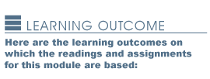  - Incorporate strategic human resource management principles in the development of programs that meet organizational needs and enable the organization to maintain a competitive advantage.  - Recommend talent management strategies that support the HR strategic plan and the competitive strategy of the organization.



Unit 5: Module 5 - Recruitment Mix

Recruitment Mix

Recruitment
There is a variety of recruitment activities, but the essential element of the recruitment mix is hiring the right people for the job. Recruiting people should be a mindful and strategic task for HR professionals.
There are four parts to recruiting:
- Research: Market trends and best practices; competitive salary and benefit packages; labor availability and qualifications.
- Criteria: Specific job requirements based on organizational needs analysis, i.e., the skills and talent required to meet organizational goals.
- Vetting: Qualifications and/or criteria that candidates must meet free of discriminatory qualifiers.
- Hiring/On-boarding: Orientation to organizational and HR policies and procedures, enrolling in benefit plans, initial training, etc.
HR managers must exercise due diligence over all parts of the recruitment process ensuring compliance with federal, state, and local laws, alignment with organizational goals, and adherence to best practices in order to be effective. Another reminder is that SHRM and ASTD provide best practices and benchmarks for talent management in reference to recruiting.
Developing a Value-Added Process
The second element in the recruitment mix is developing a value-added process to integrate strategic planning. This process involves getting “the right people into the right seats on the bus.”
HR managers must develop resources to meet the organization’s strategic planning goals and objectives. Some practices for HR managers to consider include the following:
- Regular meetings with leadership and management teams to obtain information about recruitment needs.
- Attendance at important operational meetings to keep abreast of organizational goals and strategies, the direction the organization is taking, and the skills and talent required to meet these goals.
- Participation in organizational strategic planning sessions to obtain input on training needs.
Using the navigation on the left, please proceed to the next page.

Unit 5: Module 5 - Talent Management

Talent Management

Rewards and Motivation
Once talent is recruited, it must be managed. The HR strategy must include processes and activities for motivating and rewarding employees and ensuring that their feedback is included in that process.
Such incentive systems should be designed to reward and motivate human behavior and include both monetary and nonmonetary incentives that assist HR managers to acquire and develop talent. We can refer to it as a “carrot-and-stick” approach to talent management. The carrot comprises incentives while the stick is policies and procedures. Incentives are seen as positive motivators in terms of acquiring and keeping talent in organizations.
Professional organizations such as SHRM and ASTD provide best practices and benchmarks for developing rewards and motivation.

Aligning Personal Goals with Organizational Goals
Talent management is also about making sure key personnel align their personal goals with organizational goals. That means coaching and mentoring talent through systematic means.
Coaching and mentoring can be part of a formal structured program or informally done on the job. HR managers can provide direction and resources for this process. Such programs are typically aimed at middle and top managers and executives. Coaching typically focuses on job performance; whereas, mentoring focuses on individual development (Clutterbuck, 2009).
Professional organizations such as SHRM and ASTD provide best practices and benchmarks for talent management in reference to coaching and mentoring.
Diversity
Finally, HR managers should also ensure that policies and procedures address formal and informal diversity issues. When diversity is not present in the workplace, issues arise around discrimination, fair pay, and affirmative action.
A diverse workplace includes all types of employees such as those of various races, genders, sexual orientations, ages, disabilities, and with various religious and political beliefs. Employees in a diverse workplace need to learn to work with other employees who are not the same as them.
There are best practices that can be implemented by HR managers to ensure that diversity is addressed in talent management programs including management involvement and formal training programs for managers as well as employees at large. Professional organizations such as SHRM and ASTD provide best practices and benchmarks for talent management in reference to diversity issues.
http://www.entrepreneur.com/article/75340
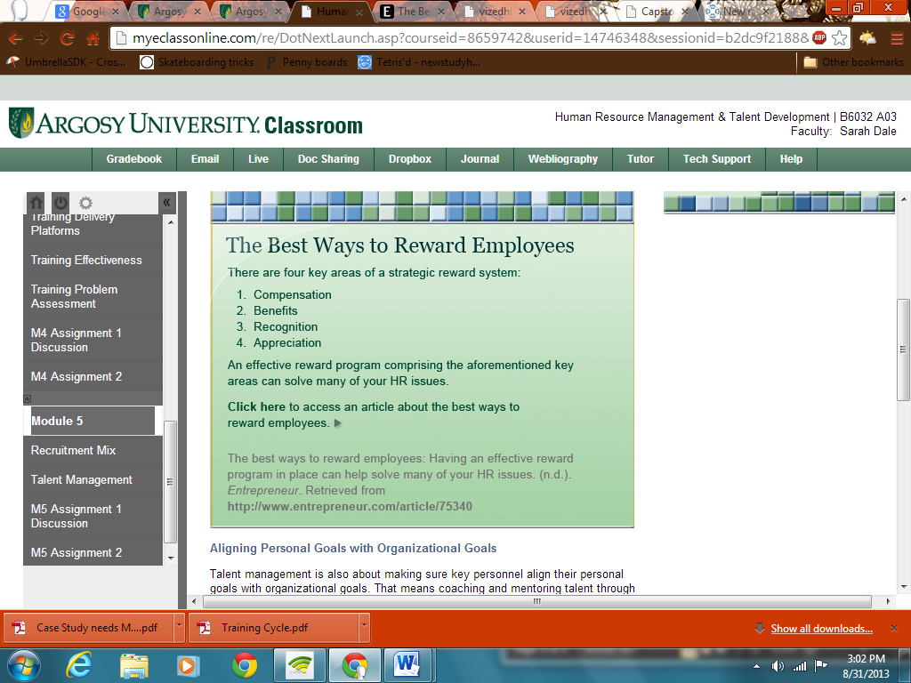

Clutterbuck, D. (2009). The use of internal resources for coaching and mentoring.Global Focus, 3, 3–6. Retrieved fromhttp://search.proquest.com/docview/215481802?accountid=34899
Using the navigation on the left, please proceed to the next page.

