**Required Readings**

* Porter, M. (1996). What is strategy? *Harvard Business Review 74*(6), 61–78. Retrieved from  [http://libproxy.edmc.edu/login?url=http://search.ebscohost.com/  
  login.aspx?direct=true&db=bsh&AN=9611187954&site=ehost-live](http://libproxy.edmc.edu/login?url=http://search.ebscohost.com/login.aspx?direct=true&db=bsh&AN=9611187954&site=ehost-live)

<http://www.huffingtonpost.com/phil-simon/technology-business-trends_b_1153832.html>

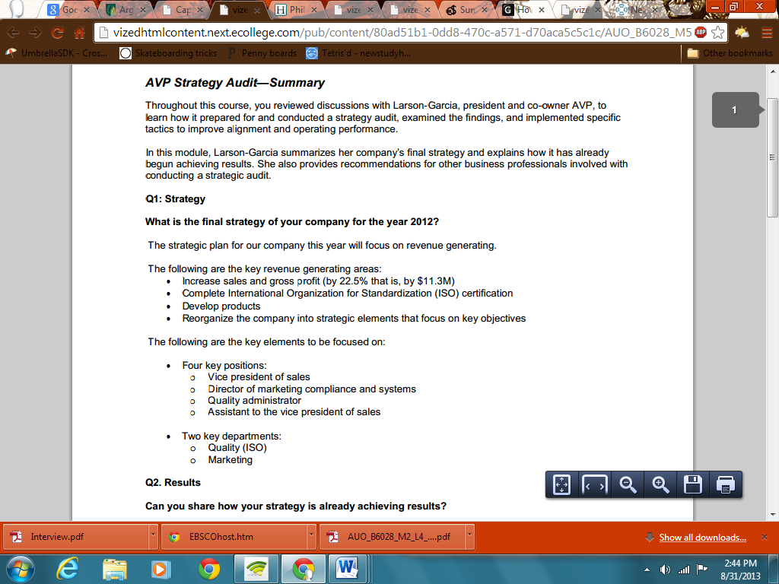

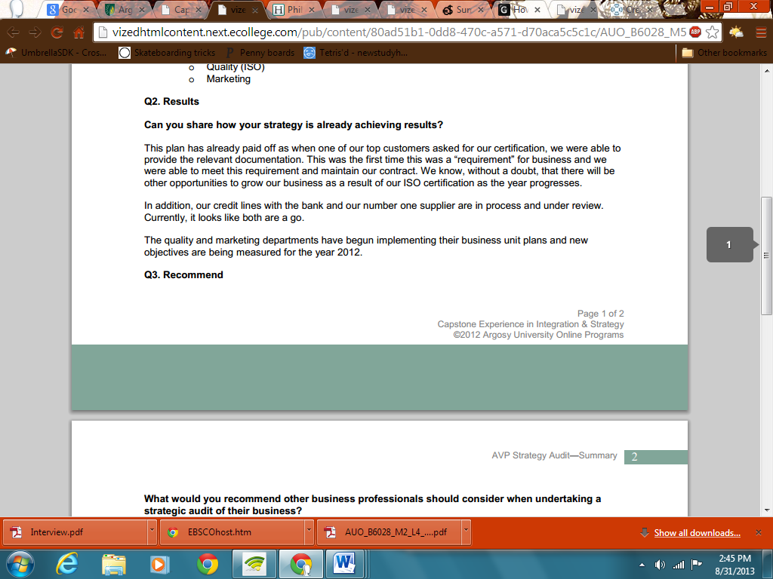

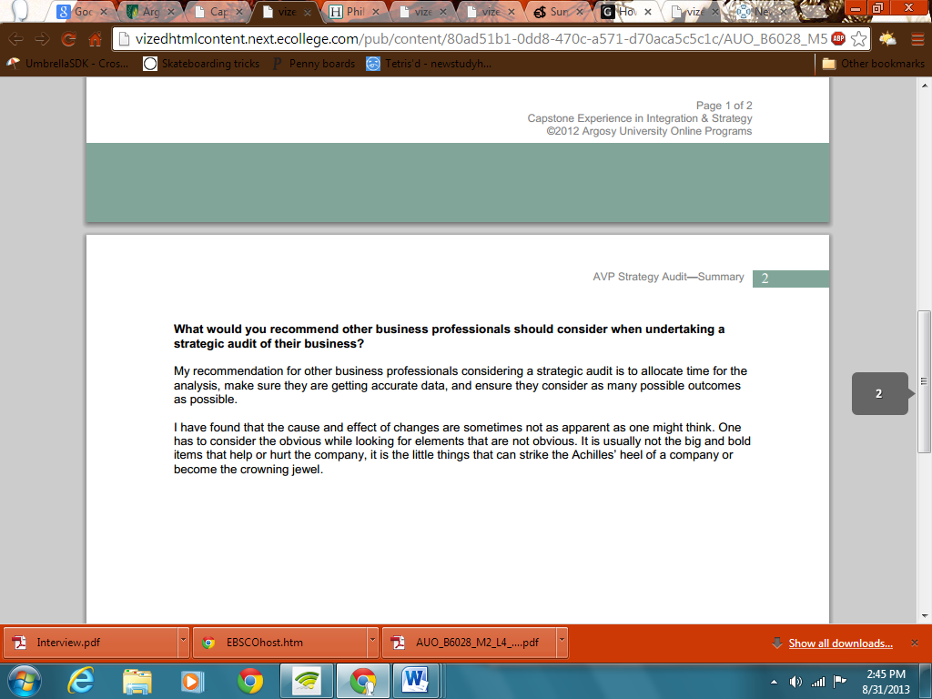

**Unit 5: Module 5 - Module 5 Overview**

|  |
| --- |
| **http://myeclassonline.com/ec/courses/AUO_files/AU_img.gifModule 5 Overview** |

|  |
| --- |
| http://myeclassonline.com/ec/courses/AUO_files/AU_spacer.gif |

|  |  |  |
| --- | --- | --- |
| This module is designed to help you explore strategic literacy. You will explore and analyze the criticality of alignment around the plan, the people or employees, demand from the marketplace, and economic indicators. Operating alignment and organizational structure and fit are key components of strategic planning. They determine which types of business model(s) and tactics are used operationally.  **Key Concepts in this Module**   * **Strategic alignment** involves ensuring the company has the right resources, market, and goals to achieve its vision through operational performance. It includes, but is not limited to, marketing, branding, alliances, mergers or acquisitions, integration, product development, diversification or divestiture, and globalization. * **Organization structure** is often dictated by the size, roles, etc. Most often, the structure is a hierarchy that arranges authority outlining or determining responsibilities, duties, and rights based on position. Structure also influences how information is shared, processes are managed, and decisions are made. Structure heavily influences how an organization operates and delivers its services and goods. * **A responsibility, authority, expertise, and work (RAEW) analysis** is the process that helps identify structural misalignments that may impede strategy execution. These include not moving fast enough with decisions, bad processes, and having the responsibility for something but not the right skill set to execute (lack of expertise). The most common issues include the following:   + Authority with no responsibility   + Responsibility with no authority   + Responsibility with no expertise   **Using the navigation on the left, please proceed to the next page.** |  | http://myeclassonline.com/ec/courses/AUO_files/LearnOutcomes_sidebar_AU.gif   * Analyze the complexity of ethical situations and corporate social responsibility and their impact on decision making in business. * Analyze and apply practical strategic business principles, models, and theories to diverse and complex organizational situations. |

|  |  |  |
| --- | --- | --- |
| http://myeclassonline.com/ec/courses/AUO_files/AU_spacer.gif |  | http://myeclassonline.com/ec/courses/AUO_files/AU_spacer.gif |
| [http://myeclassonline.com/ec/courses/AUO_files/au_cnt_alert.gif](javascript:;) |  | Help Desk 1-888-720-6654 |

# Unit 5: Module 5 - Strategic Literacy and Performance

|  |
| --- |
| **http://myeclassonline.com/ec/courses/AUO_files/AU_img.gifStrategic Literacy and Performance** |

|  |
| --- |
| http://myeclassonline.com/ec/courses/AUO_files/AU_spacer.gif |

|  |  |  |
| --- | --- | --- |
| Strategic literacy refers to the ability of the people or employees within an organization to understand and execute to the company’s business goals (Tailwind Consulting, 2011). It is critical that everyone, no matter at what level in the organization, is literate about the company goals and how their job relates to impacting the goals and the overall performance of the organization.  As you have learned throughout this course, an understanding of internal and external factors and alignment around a right-fit strategy is critical. All too often, companies are aligned around the mission and values, but not necessarily around the long-term strategy. Problems arise when companies are not aligned with the critical strategic imperatives needed to achieve the vision. Often, executives and managers might agree on the “what” but not on the “how.”  The vision for any business needs to be translated into a workable framework that everyone can understand and ultimately execute. Senior leaders often struggle with getting everyone on the same page so they are engaged and fully aligned. Enabling your team to collaborate around a single strategy involves a lot of moving parts.  **Strategic Performance**  Strategic performance is what occurs between your intent—what you want to do—and its execution by your people. The translation process is essential and constantly has to be managed to ensure total organizational alignment. Without a managed process that gets regular attention, there are too many opportunities for misinterpretation. This results in misalignment and fake work where employees do work not related to the goals and strategic direction of the company.  Tailwind Consulting. (2011). Introducing strategic literacy. Retrieved from<http://www.slideshare.net/TailwindConsulting/strategic-literacy>  **Using the navigation on the left, please proceed to the next page.** |  |  |

|  |  |  |
| --- | --- | --- |
| http://myeclassonline.com/ec/courses/AUO_files/AU_spacer.gif |  | http://myeclassonline.com/ec/courses/AUO_files/AU_spacer.gif |
| [http://myeclassonline.com/ec/courses/AUO_files/au_cnt_alert.gif](javascript:;) |  | Help Desk 1-888-720-6654 |

# Unit 5: Module 5 - Your Strategy Audit

|  |
| --- |
| **http://myeclassonline.com/ec/courses/AUO_files/AU_img.gifYour Strategy Audit** |

|  |
| --- |
| http://myeclassonline.com/ec/courses/AUO_files/AU_spacer.gif |

|  |  |  |
| --- | --- | --- |
| A strategy audit involves assessing the actual direction of a business and comparing that course to the direction required to succeed in a changing environment. A company's actual direction is the sum of what it does and does not do, how well the organization is internally aligned to support the strategy, and how viable the strategy is when compared to the external market, competitors, and financial realities. These two categories, the internal assessment and the external or environmental assessment, make up the major elements of a strategy audit.  In this module, you will deliver your strategy audit as LASA 2. This audit is considered as some of the most important work in your MBA program. The ability to conduct a strategy audit further positions you, as the learner, as not just being able to understand but to take the knowledge and execute into action. This is where theory and concept make meaning as they are translated into actionable results. In the marketplace, knowledge and understanding are critical, but even more so is the ability to apply and “do” something that enables the organization to assess, realign, and take action to thrive and grow.  **Strategic Audit and Strategy Maps**  The strategy audit is a comprehensive analysis of the company’s business strategy and operating performance. It culminates in a series of recommendations for improving a company’s performance based on the findings and conclusions of a thorough analysis. Whether you are an experienced or developing business professional, by completing this important project, you have added to your portfolio of critical business skills.  **Using the navigation on the left, please proceed to the next page.** |  |  |

|  |  |  |
| --- | --- | --- |
| http://myeclassonline.com/ec/courses/AUO_files/AU_spacer.gif |  | http://myeclassonline.com/ec/courses/AUO_files/AU_spacer.gif |
| [http://myeclassonline.com/ec/courses/AUO_files/au_cnt_alert.gif](javascript:;) |  | Help Desk 1-888-720-6654 |

# Unit 5: Module 5 - The Role of Ethics

|  |
| --- |
| **http://myeclassonline.com/ec/courses/AUO_files/AU_img.gifThe Role of Ethics** |

|  |
| --- |
| http://myeclassonline.com/ec/courses/AUO_files/AU_spacer.gif |

|  |  |  |
| --- | --- | --- |
| Whether formally or informally stated in a business, ethics play an important part in overall long-term success. The lack of ethical behavior and policy can drive employee behavior and organizational results to dangerous places that can result in illegal activities, such as fraud and harassment. Having a defined ethics and code-of-conduct policy that is clear to all levels and is enforced can help an organization prevent such issues. In addition, it can establish a culture of expectation around the right and wrong behavior for a specific organization as well as its industry.  **Employee Behavior**  Behavior is typically looked at in several forms in an organization: productive producer, stagnant, and disruptive. The goal is to create productive producers; however, it is often the case where behavior has to be managed and dealt with to correct performance that is stagnant or disruptive. Stagnant and disruptive behaviors do not align with the strategy or help deliver the results. Promoting positive behavior by clearly sharing the strategy and helping employees align and play a role in executing to deliver the results is critical. The lack of any of the three noted areas can create issues in employee behavior.  **Evaluating the Role of Ethics**  Miriam Schulman, communications director of the Markkula Center for Applied Ethics advises that as we evaluate the role of ethics in business, it is important to understand that an organization can prescribe a specific set of standards by which individuals in the organization are to operate. However, the reality is that the behavior of all leaders in the organization must mirror the standards and must be a pervasive part of the culture, business strategy, purpose, and values in order to be an organizational reality and have impact. In essence, the role of ethics has to be built into the strategic plan.  Keep these thoughts in mind as you prepare your final assignment in the course and as you continue in your business career.  Schulman, M. (2006). Incorporating ethics into the organization's strategic plan. The Markkula Center for Applied Ethics. Retrieved from<http://www.scu.edu/ethics/practicing/focusareas/business/strategic-plan.html>  **Using the navigation on the left, please proceed to the next page.** |  |  |

|  |  |  |
| --- | --- | --- |
| http://myeclassonline.com/ec/courses/AUO_files/AU_spacer.gif |  | http://myeclassonline.com/ec/courses/AUO_files/AU_spacer.gif |
| [http://myeclassonline.com/ec/courses/AUO_files/au_cnt_alert.gif](javascript:;) |  | Help Desk 1-888-720-6654 |