Unit 2: Module 2 ()
- From Managing human resources: Productivity, quality of work life, profits (9th ed.), read the following chapters:
  - Pay and incentive systems
  - Indirect compensation: Employee benefit plans

Module 2 Overview

In this module, you will learn about the strategic, operational, and tactical compensation and benefits tools HR managers use in talent management. HR managers use a mix of compensation and benefits as incentives and motivators. A key role for HR managers is to devise an incentive system that rewards and motivates human behavior, which includes monetary and nonmonetary incentives that assist HR managers to acquire and develop talent.  HR strategy and HR managers utilize a carrot-and-stick approach to motivate employees. The carrot symbolizes incentives whereas the stick symbolizes policies and procedures. Incentives are seen as positive motivators in terms of acquiring and keeping talent in organizations whereas rules help in keeping control over employees.  Professional organizations such as the Society for Human Resource Management (SHRM) and the American Society for Training and Development (ASTD) provide best practices and benchmarks in employee motivation and development. HR professionals may refer to these resources for talent management.  In the first assignment of this module, you will discuss and evaluate the compensation and benefits that motivate employees. In the second assignment, you will analyze the impact of acquisition and mergers on paid time off (PTO) policies of an organization. You will also recommend a common PTO system, keeping in mind the policies of two merged companies.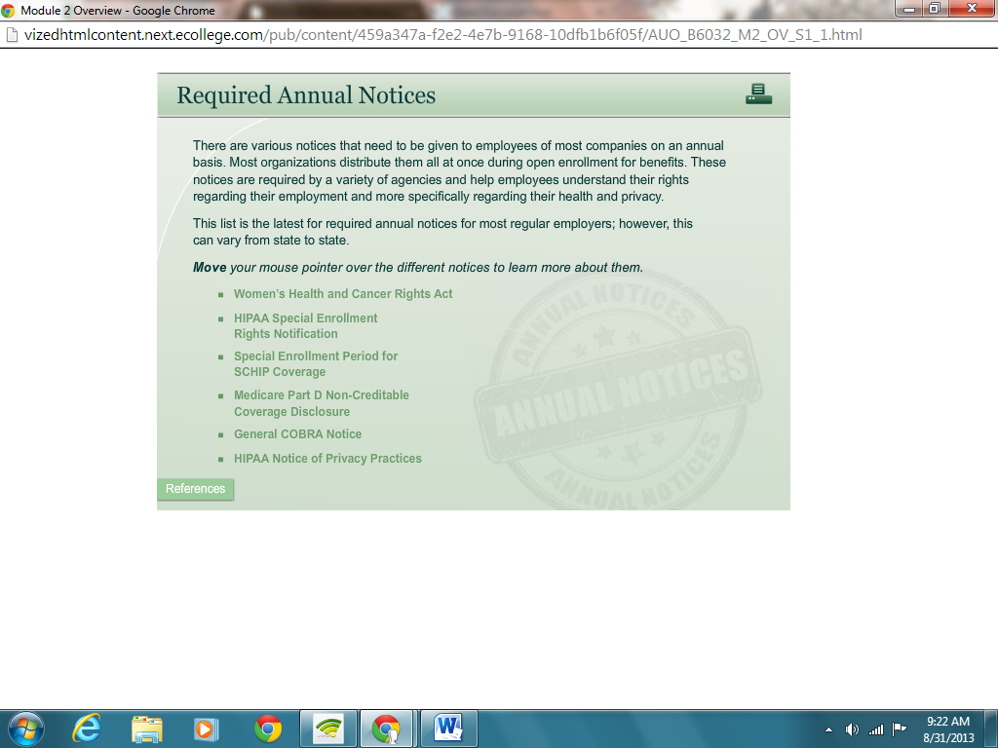  Using the navigation on the left, please proceed to the next page. |  |   - Incorporate strategic human resource management principles in the development of programs that meet organizational needs and enable the organization to maintain a competitive advantage.  - Recommend talent management strategies that support the HR strategic plan and the competitive strategy of the organization.



Unit 2: Module 2 - Compensation and Benefits

Compensation and Benefits

- 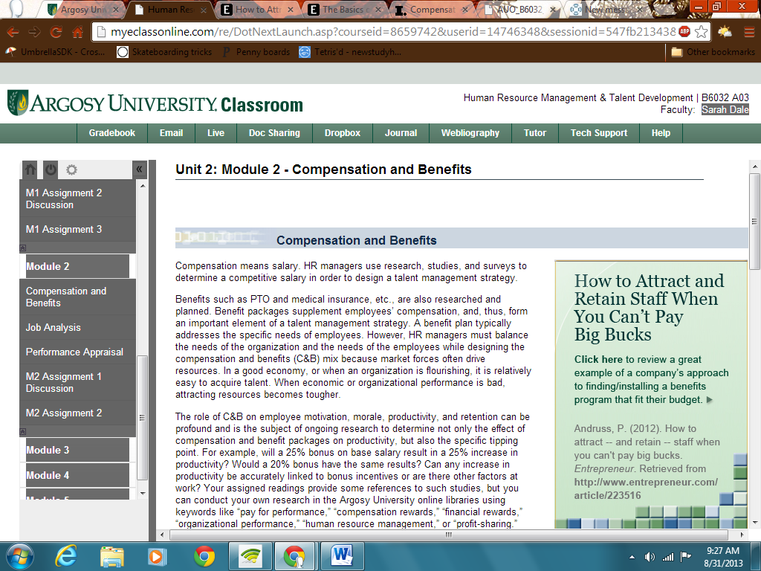
- http://www.entrepreneur.com/article/223516

Compensation means salary. HR managers use research, studies, and surveys to determine a competitive salary in order to design a talent management strategy.
Benefits such as PTO and medical insurance, etc., are also researched and planned. Benefit packages supplement employees’ compensation, and, thus, form an important element of a talent management strategy. A benefit plan typically addresses the specific needs of employees. However, HR managers must balance the needs of the organization and the needs of the employees while designing the compensation and benefits (C&B) mix because market forces often drive resources. In a good economy, or when an organization is flourishing, it is relatively easy to acquire talent. When economic or organizational performance is bad, attracting resources becomes tougher.
The role of C&B on employee motivation, morale, productivity, and retention can be profound and is the subject of ongoing research to determine not only the effect of compensation and benefit packages on productivity, but also the specific tipping point. For example, will a 25% bonus on base salary result in a 25% increase in productivity? Would a 20% bonus have the same results? Can any increase in productivity be accurately linked to bonus incentives or are there other factors at work? Your assigned readings provide some references to such studies, but you can conduct your own research in the Argosy University online libraries using keywords like “pay for performance,” “compensation rewards,” “financial rewards,” “organizational performance,” “human resource management,” or “profit-sharing.”
Executive Compensation
Executive compensation is about talent acquisition and development. It is strategic in nature and incentive based. Executive compensation is about getting and retaining the best talent available. Many executive compensation plans are based on market value and is often about pay for performance.
http://www.inc.com/guides/hr/20678.html
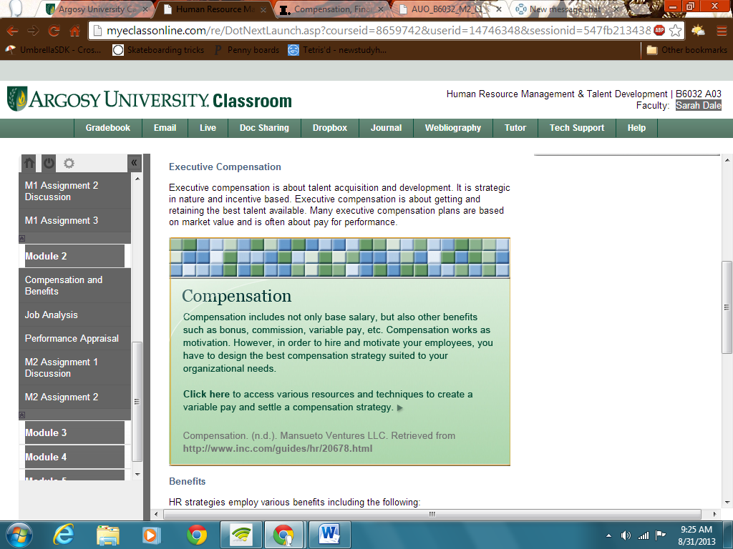
Benefits
HR strategies employ various benefits including the following:
- Medical benefits: Medical benefits are usually provided for all employees and include comprehensive and/or major medical insurance. Employees may be given choices between service providers and insurance riders where possible.
- Insurance: There are various types of insurances, and employees may have a say in the type of insurance they want to avail.
- Pensions: This includes retirement benefits, with a choice of options when possible.
- 401Ks: This includes retirement benefits, with a choice of options when possible.
- Time off: Employees may receive various options for time off work such as sick leave, personal leave, vacations, holidays, and sabbaticals.
- Lifestyle benefits: This includes incentives such as restaurant vouchers, movie tickets, membership to social clubs, and so on.
- Wellness/childcare: This includes memberships to gyms, health clubs, child care facilities, and so on.
- Flex benefits: This includes options such as telecommuting, and flexible working hours depending on the employee’s convenience.
http://www.entrepreneur.com/article/80158
- 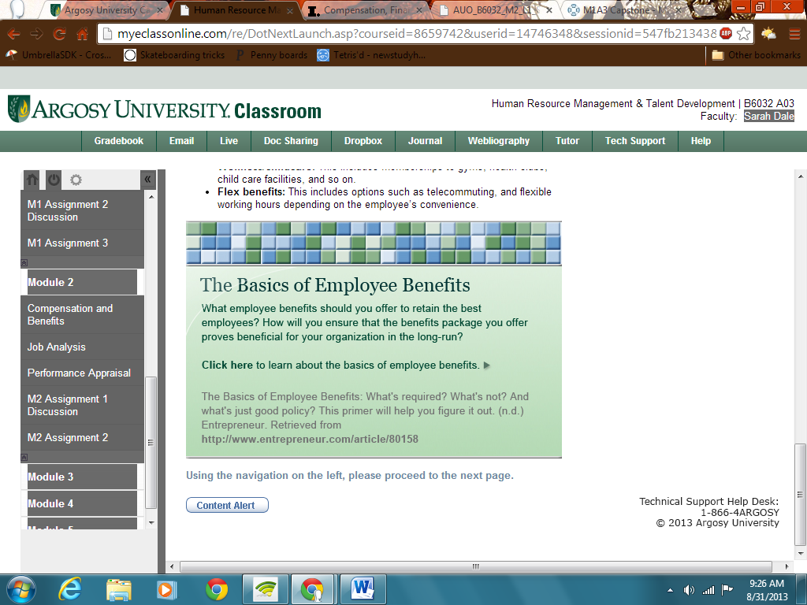

Using the navigation on the left, please proceed to the next page.

Unit 2: Module 2 - Job Analysis

Job Analysis

Job analysis in an important tool in talent management. This process serves to identify the activities involved in a job and the skills required to perform it. It helps HR managers select the right personnel for the right job. Job analysis should be performed on a need basis, and the process should be continually improved.
There are three parts to the job analysis process:
- Needs analysis: A needs analysis entails gathering data and developing goals and objectives. It helps understand the needs of the job. O’Connor (2006) summarized a simplified three-step approach to needs assessment:
  - Identify the problems, issues, challenges, goals, and priorities of the business.
  - Uncover gaps in performance areas.
  - After determining causes of the problems, recommend solutions. (O’Connor, 2006, pp. 14–17)
- Job description: A job description is a document that describes the role, duties, and responsibilities of the job and explains the skills and activities required to perform the job. The job description provides all the information related to the job such as designation, location, nature of the job, and qualifications required for the job. It also explains the authority-responsibility relationship with internal and external people.
- Evaluation and Assessment: This is the last stage of the job analysis process. Evaluation and assessment make sure that the job description is reviewed periodically to maintain its effectiveness. This process, when implemented correctly, leads to better workforce management.
The job analysis process assists HR in developing accurate job descriptions. It also helps them conduct employee recruitment and evaluation. However, HR personnel should be cautious to evaluate only the job and not the employees while performing the job analysis.
O’Connor, J. (2006). Shifting mindsets. E.Learning Age, 14–17. Retrieved fromhttp://search.proquest.com.libproxy.edmc.edu/docview/200863208/
abstract?source=fedsrch&accountid=34899
Using the navigation on the left, please proceed to the next page.

Unit 2: Module 2 - Performance Appraisal

Performance Appraisal

Performance appraisals are snapshots of performance over a period of time. They are conducted at periodic intervals or by triggering planned or situational events.
Performance appraisals are conducted during a given period to gauge progress and/or at the end of a period to review the employees’ performances. The appraisals can be carrot and stick (reward and/or punishment) or purposive (that is, ranking for advancement).
The process of performance appraisal seeks to evaluate the performance of employees and understand their needs and abilities for further growth and development. Performance appraisal serves the following objectives:
- To revise employees’ compensation and work profile as per industry standards
- To provide feedback to employees about their performance with respect to the organization’s expectations
- To assess the strengths and weaknesses of employees for further growth and development
- To measure the potential in employees to take up the next challenging role or assignment
Performance appraisals offer several advantages to the organization:
- Compensation: Performance appraisals allow HR to outline compensation packages for employees based on their performance. The compensation package includes bonus, high salary rates, extra benefits, allowances, and pre-requisites, all of which are dependent on the performance appraisal.
- Employee Development: Performance appraisals help supervisors recognize the training needs of employees based on their strengths and weaknesses and identify the required training programs for their development.
- Promotion: Performance appraisals help supervisors identify efficient employees and design a promotion plan for them. It also helps them recognize inefficient employees and chalk out an appropriate plan for their development.
- Motivation: Performance appraisals help measure the efficiency of employees if targets assigned to them are met. This helps motivate employees to improve their performance in the future.
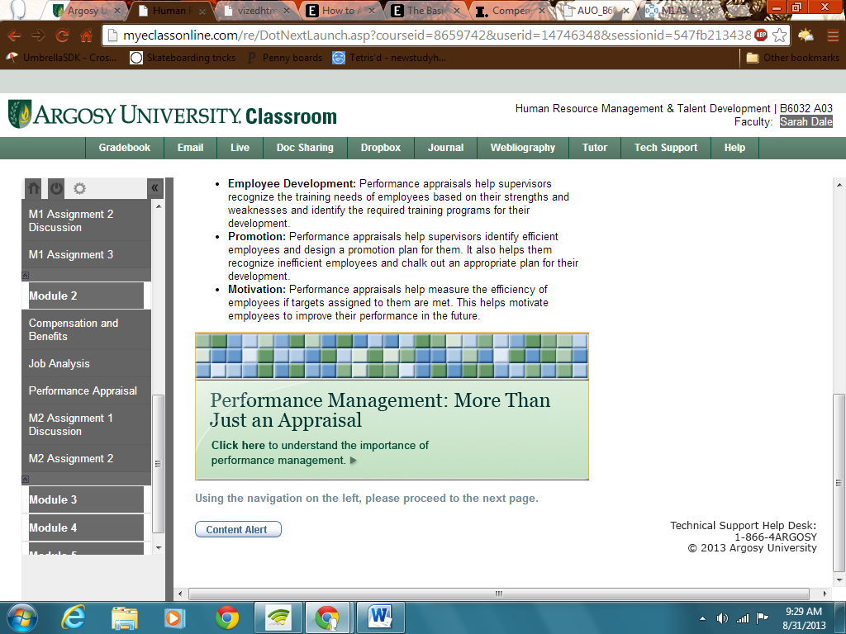
Using the navigation on the left, please proceed to the next page.

